**Aim:**

we have been given a “diabetes.csv” data file .This dataset is originally from the National Institute of Diabetes and Digestive and Kidney Diseases. The objective of the dataset is to diagnostically predict whether or not a patient has diabetes, based on certain diagnostic measurements included in the dataset. Several constraints were placed on the selection of these instances from a larger database. In particular, all patients here are females at least 21 years old of Pima Indian heritage.

And hence we need to apply at minimum 2 classification algorithms and compare their respective accuracies.

**Preview:** this project classifying whether a person has diabetes or not considering the different data columns given in the csv file that where:

“pregnancies” , “glucose”, “blood pressure” , “skin thickness”, “ insulin” , “BMI”, ”diabetes pedigree function” and “age” .

We tend to find out the relation and apply 4 machine learning algorithms to the following dataset in order to predict their respective accuracies and hence point out the best prediction algorithm among them.

**Tools used:**

There are a number of tools used for completing this major project some of them being as follows :

Pandas – for implementing fataframe structures and using it to store the values of the given csv files ( eg: pd.read_csv(“file_path”) )

Matplotlib – for implementing graphical representation of the results as well as the analysis as it helps us to get a clear overview and errors in the data.

Sklearn – this library seems to help us a lot from data pre processing for generating usable data to dividing test and train data to implementing the 4 classification algorithms it helps us access pre defined classes for classifying data.

Python – is the programming language we have used to write the code implementing the machine learning concepts.

**Pre-processing and understanding:**

We analyse the data before applying the algorithms to the dataset for machine learning. While analysing I plotted histograms to possibly guess important factors.

We also got abnormal values where BMI , glucose and skin thickness were 0 and insulin being 0 wasn’t an uncommon phenomenon .

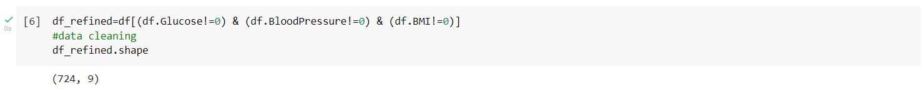

so we cleaned the data accordingly and then divided the it into train and test parts further scaling them relatively using StandardScaler.

**Algorithms :**

In this project I have implemented 4 classification algorithm:

1. Logistic regression : the logistic model is used to model the probability of a certain class or event existing such as pass/fail, win/lose, alive/dead or healthy/sick. Basically it points the data points in a 2 dimensional graph and divides it into 2 classes like here being diabetic or not.
2. Decision tree : A decision tree is a decision support tool that uses a tree-like model of decisions and their possible consequences, including chance event outcomes, resource costs, and utility.it creates conditional clauses in a tree like format with a specific priority order helping us to classify the given dataset.
3. Random forest : Random forests or random decision forests are an ensemble learning method for classification, regression and other tasks that operates by constructing a multitude of decision trees at training time. For classification tasks, the output of the random forest is the class selected by most trees.
4. Text

   Description automatically generatedSupport vector machines : In machine learning, support-vector machines are supervised learning models with associated learning algorithms that analyse data for classification and regression analysis. Here we have classified the data into 2 parts.

**CONCLUSION :**

We applied the 4 classification algorithms for the given diabetes dataset and found their respective accuracies which are :

Logistic regression : 78.24 %

Decision tree : 69.04 %

Random forests : 75.73 %

Support vector machines(classifier) : 76.57 %

